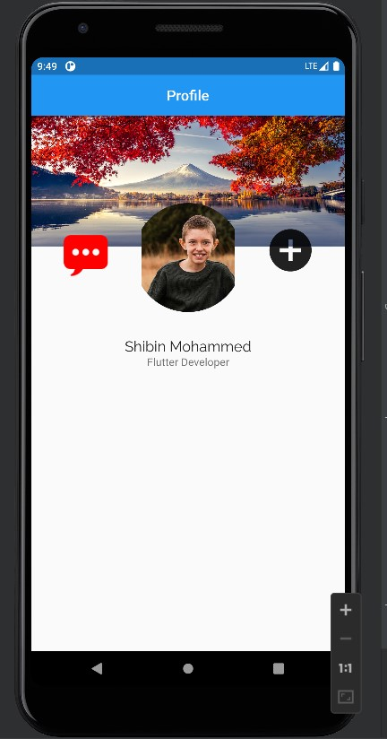

import 'package:flutter/cupertino.dart';  
import 'package:flutter/material.dart';  
  
void main(){  
 runApp(MaterialApp(  
 debugShowCheckedModeBanner: false,  
 home: ProfileS(),  
 ));  
}  
  
class ProfileS extends StatefulWidget{  
 @override  
 State<StatefulWidget> createState() => _ProfileSState();  
  
}  
  
class _ProfileSState extends State<ProfileS> {  
 @override  
 Widget build(BuildContext context) {  
 return Scaffold(  
 appBar: AppBar(title: Text('Profile'),  
 centerTitle: true,),  
 body: Stack(  
 alignment: Alignment.*center*,  
 children: <Widget>[  
 Column(  
 children: [  
 Image.network(  
 'https://helpx.adobe.com/content/dam/help/en/photoshop/using/convert-color-image-black-white/jcr_content/main-pars/before_and_after/image-before/Landscape-Color.jpg',  
 height: 180,  
 width: double.*infinity*,  
 ),  
 ],  
 ),  
Positioned(  
 top: 120,  
 child: Column(  
 children: [  
 Container(  
 height: 150,  
 width: 200,  
 decoration:const BoxDecoration(  
 shape: BoxShape.circle,  
 image:DecorationImage(  
 image: NetworkImage('https://media.npr.org/assets/img/2022/07/09/292393717_572613227568467_4128593112564682711_n_custom-1c4747f8862d5f8b3b0137378dc87a2461d63425-s1100-c50.jpg'  
 ),  
 ),  
 ),  
 ),  
 ],  
 ),  
 ),  
  
 Positioned(  
 right: 40,  
 top: 150,  
 child: Column(  
 children:const [  
 Icon(Icons.*add_circle*,size: 70,),  
 ],  
 ),  
 ),  
  
 Positioned(  
 left: 40,  
 top: 140,  
  
 child: Column(  
 children: [  
 Image.asset("assets/images/msg.png",  
 height: 100,  
 width: 70,  
 ),  
  
 ],  
 ),  
 ),  
  
const ListTile(  
 contentPadding:EdgeInsets.only(bottom: 80),  
 title: Text('Shibin Mohammed',textAlign: TextAlign.center,  
 style: TextStyle(fontSize: 20,  
 fontFamily: 'Raleway',  
 fontWeight: FontWeight.*w500*,),),  
subtitle: Text('Flutter Developer',textAlign:TextAlign.center,  
 style:TextStyle(fontSize: 15),), ),  
  
 ],  
 ),  
 );  
 }  
}